Operation Ashiba
Basic Facts | June 2020

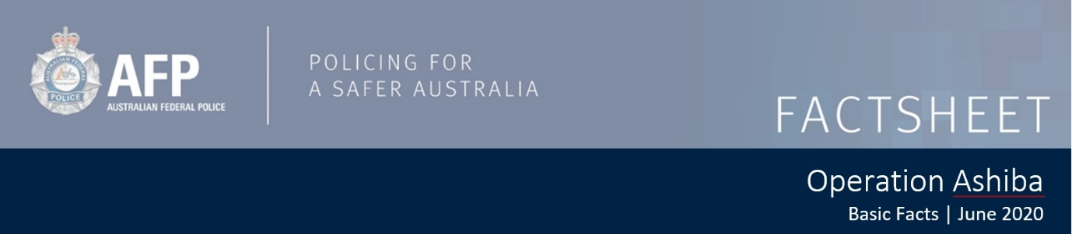
Operation Ashiba – Basic Facts
Operation Ashiba has been established to support and contribute to whole-of-government efforts to combat serious and organised crime exploiting Commonwealth funded programs. The establishment of Operation Ashiba aims to strengthen Commonwealth counter fraud arrangements.

What is Operation Ashiba?
Operation Ashiba is an AFP-led multi-agency taskforce that includes:
- Australian Criminal Intelligence Commission (ACIC)
- Australian Securities and Investments Commission (ASIC)
- Australian Transaction Reports and Analysis Centre (AUSTRAC)
- Department of Agriculture
- Department of Defence
- Department of Education, Skills and Employment
- Department of Health
- Department of Social Services
- National Disability and Insurance Agency
- Services Australia
The taskforce works in partnership with other agencies including:
- Australian Competition and Consumer Commission (ACCC)
- Australian Taxation Office
- State and territory law enforcement
As a multi-agency taskforce, Operation Ashiba leverages the individual and collective powers, capabilities, knowledge and experience of participating agencies and partners.

Why do we need Operation Ashiba?
The Australian Government uses grants and financial support measures to assist workers, businesses and the broader community experiencing hardship. Historically, organised criminals have attempted to commit fraud against emergency and ongoing financial support measures.

What are Operation Ashiba’s objectives?
Operation Ashiba will work with our intelligence and investigations community to probe and better understand the criminal operating environment. We will improve our collective situational awareness and share this with our participating agencies and partners to provide a common foundation for our efforts.

Operation Ashiba’s objectives are to:
- Build a better operational intelligence picture of national fraud threats including serious and organised crime.
- Identify disruption opportunities across the Commonwealth in association with funded programs.
- Engage domestic and international partners to assist in a coordinated and cohesive response to fraud threats.
- Develop strategic disruption and deterrence initiatives to inform fraud prevention and control efforts.

What can you do?
It is important for all Australians to report any information or suspicion of a financial crime or unusual activity.
Fraud can be reported anonymously to Crime Stoppers via their website www.crimestoppers.com.au
Further information on how to report fraud can be found at:
- www.ag.gov.au/Integrity/counter-fraud/Pages/reporting-fraud.aspx
- www.servicesaustralia.gov.au/individuals/contact-us/reporting-fraud

Other useful information:
- Scamwatch can provide you with information about new scams, how to protect yourself against scams and how to report a scam www.scamwatch.gov.au
- iDCARE can help you to protect your identity against identity theft, and recover if you have had your identity stolen www.idcare.org
- If you have been the victim of cybercrime, you can report it at: www.cyber.gov.au/report
- Further information on staying safe online can be found at: www.staysmartonline.gov.au

