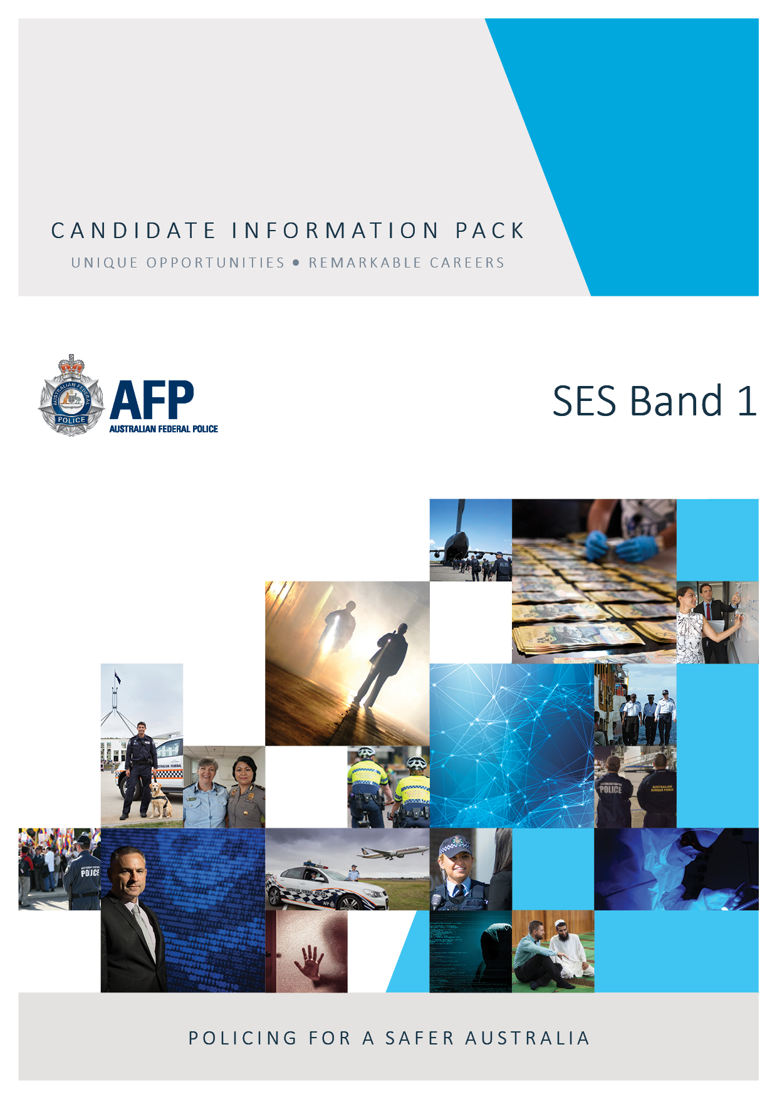
Join our team
Superintendent
Human Intelligence & Undercover Program
Superintendent
September 2020

The AFP's role is to enforce Commonwealth criminal law, contribute to combating complex, transnational, serious and organised crime impacting Australia's national security and to protect Commonwealth interests from criminal activity in Australia and overseas. The AFP prides itself on demonstrating leadership and agility in a dynamic operating environment.
We are action orientated, ethical and values-driven, embracing diversity and inclusion. We value fairness, trust, respect, accountability, integrity, commitment and excellence in service to the community and in working with each other.

The Mission
As Australia’s national policing agency we protect Australians and Australia’s interests.
What we do
- Combat complex, transnational and organised crime and terrorism
- Disrupt crime offshore and support regional security as Australia’s principal international law enforcement representative
- Protect Australian high office holders, foreign dignitaries, Australian government infrastructure, and designated international airports.
- Provide policing services to the Australian Capital Territory, Jervis Bay and Australia’s external territories.
Our Approach – Through leadership, collaboration and innovation we:
- Adapt by being intelligence informed
- Build partnerships in Australia and abroad
- Drive Australia’s international policing interests to combat crime
- Develop leading-edge policing capabilities and knowledge

The role
This role reports to the Commander Human Intelligence and Undercover Program (HUMINT and UCP) of the AFP and is responsible for directing and leading a range of activities in this function, and providing specialist advice on HUMINT and UCP capabilities in support of AFP investigations and intelligence collection activities.
This role requires strong staff management skills, and supports Australian Federal Police Commands and partners in the delivery of HUMINT and UCP capabilities. The Superintendent leading HUMINT and UCP must possess formal HUMINT and UCP qualifications (Undercover, Human Source Management), and possess extensive experience in the management of HUMINT and UCP operations and activities. It is highly desirable to possess a Detective designation.

Essential requirements
- You must be an Australian citizen to work for the AFP.
- Top Secret Negative Vetting (NV2) security clearance or ability to obtain one;
- Proven and extensive experience leading and managing HUMINT and UCP operations and activities;
- Formal HUMINT and UCP qualifications (Human Source, Undercover);
- Extensive experience in managing a range of law enforcement operations;
- Demonstrated high level of integrity and accountability, and ability to work in a high security environment;
- Demonstrated ability to lead personnel and develop productive working relationships;
- Demonstrated ability to collaborate with internal and external partners;
- Must have been a sworn police officer in the last 3 years;
- Ability to be sworn in as a member of the AFP pursuant to the AFP Act 1979 (Cth); and
- Ability to be declared a Commissioner Officer with the rank Superintendent.

Our ideal candidate
As a leader within the AFP you will:

- support the strategic direction;
- be able to implement and lead innovation and continuous improvement within the AFP;
- have the ability to develop and motivate people;
- have strong stakeholder relationship skills;
- be forward thinking and self-motivated; and
- lead by example, embodying the inclusive culture to which we aspire.

rOLE sCOPE

As a Superintendent in the AFP, you will ensure that the achievement of outcomes is in accordance with the regulatory framework, the AFP Code of Conduct and the AFP Governance instruments. This role requires the occupant to be declared as a sworn member and a Commissioned Officer with the rank of Superintendent.
Superintendent HUMINT and UCP responsibilities are to:

- Lead and manage the delivery of AFP HUMINT and UCP capabilities;
- As a member of the HUMINT and UCP Executive, operate under delegated authority, managing the operation of a number of specialist areas while supporting the AFP Senior Executive in the shaping of strategic initiatives;
- Work closely with AFP Commands, other specialist capabilities, and external partners to effectively deliver HUMINT and UCP outcomes;
- Represent the AFP in relevant HUMINT and UCP disciplines and liaison forums whilst maintaining and developing collaborative working relationships;
- Develop, execute and evaluate strategy in consultation with key stakeholders;
- Develop the HUMINT and UCP workforce and fulfil a mentoring role;
- Maintain excellent contemporary knowledge of HUMINT, UCP and criminal investigations related legislation, regulations and policy;
- Apply the AFP Performance Management Framework;
- Record and maintain information in accordance with AFP requirements;
- Manage and develop relevant governance and policy;
- Manage the requirements and recommendations of related oversight functions, and
- Maintain and enhance a professional culture based on the AFP’s core values, ensuring high levels of community confidence in the integrity, effectiveness and accountability of the AFP and its members.

Our Offer
Attractive remuneration packages are available, with the terms and conditions of service as contained in the AFP Executive Level Enterprise Agreement 2019-2021.

More Information
The AFP is part of the Home Affairs portfolio and works closely with a range of other law enforcement and government agencies at state, territory, Commonwealth and international levels, enhancing safety and providing a secure regional and global environment.
The Corporate Plan is a legislative requirement under the Public Governance, Performance and Accountability Act 2013. It sets out the AFP’s purpose, priorities, environmental context, the activities it undertakes, how performance is measured and the management approach to risk.
The plan is a rolling four-year plan and is updated annually. It is aligned with the outcome statements, program and performance information presented in the AFP Portfolio Budget Statements. Performance against the plan and the PBS is reported in the Annual Report.

Diversity
Diversity is a core element of modern policing. Not only does it ensure we reflect the community we serve, it also allows the AFP to build and maintain community trust, and strengthens our capacity to effectively respond to local, national and international challenges. Achievement of a diverse workforce, and an inclusive workforce culture, are not merely nice to have – they are imperative to our capability as an effective, future- ready police organisation.

Further reading
- Platypus: Policing and community news from the Australian Federal Police
- AFP Media releases

How to apply
To apply:
- Provide an application of no more than two pages outlining why you are attracted to the role or organisation and what you bring to the role, taking into consideration the role description and Executive Level Work Level Standards.
- Provide a copy of your Curriculum Vitae (CV) of maximum 3 pages.
- Assessment by the Selection Advisory Committee (SAC) will be in accordance with the AFP National Guideline on Recruitment.
- Shortlisted candidate assessment will include a formal interview, referee feedback will be sought, and psychometric profiling. Candidates with also be required to pass medical and integrity checks.

How to lodge your application/application format
Applications will only be accepted through the AFP’s online recruitment website:
https://www.afp.gov.au/careers/vacancies
Position contact: Mr Anthony Fox - Anthony.Fox@afp.gov.au
Applications close: 11:59pm (AEDT) ??? 2020.
Late applications will not be considered without the explicit approval of the Selection Committee Chair.

